Department Chairs’ Meeting Minutes
October 10, 2010 -- 9:35 a.m.
Battle Mountain - #4; Elko- EIT #203; Ely - #118; Pahrump – PVC #122; Winnemucca - #202

Chair: B. Hofland

Present: P. Bagley, L. Campbell, N. Cavanaugh, F. Daniels, M. Doucette, D. Ellefsen, P. Fox, D. Freistroffer,
T. Matula, C. Mitchel, B. Murphy, E. Nickel, M. Swetich, L. Uhlenkott, B. Verbeck, N. Whittaker

Absent: A. DeBraga, A. Donnelli, X. Du, L. Frazier, D. Gonzales, M. Lasalle-Walsh

Guests: Cliff Ferry, Sarah Negrete, Barbra Moss,

- Dept strategic plans & chairs’ responsibilities –
Cliff Ferry gave a background of strategic planning. In the accreditation visit in 2003 there was a continued push for assessment & planning. That led to our first full strategic plan as a college as a whole. 2004-2009 dealt with programs at the VP level. That plan ended in Spring 2009. During 2009 another Strategic Plan was started that was more ambitious. A plan for the next 5 years was approved by the Board of Regents last summer. Focus is on planning & assessment. What is the best way to work out technicalities? Talk about issues, missions, goals, and objectives. Chancellor, Board of Regents and accreditation people like to see planning. This is developmental and not easy. The plan is a living document and should change with the institution.
Cliff will only be available via email or telephone for the next 5-6 months. Meet with Cliff about individual department’s strategic plan.
Handout:

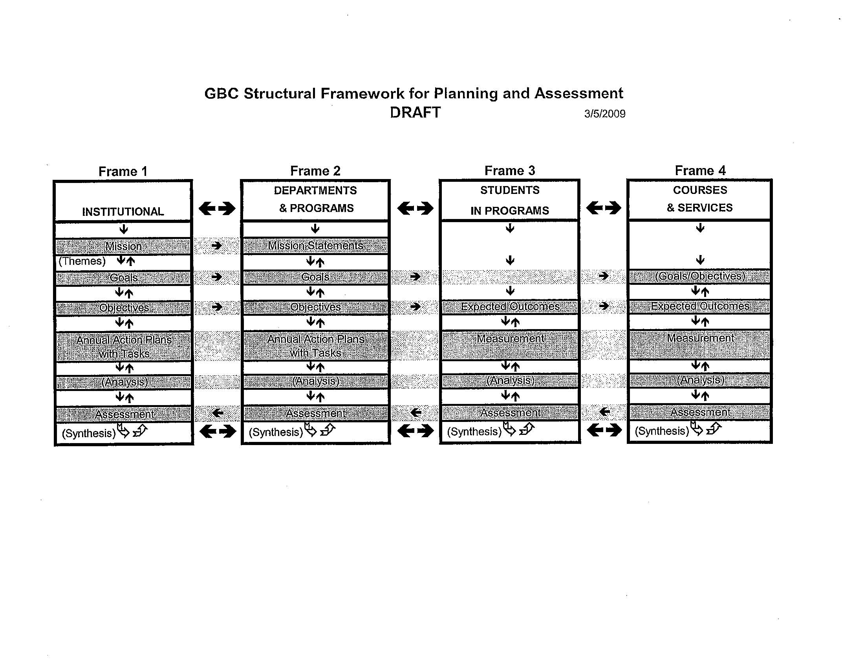

Discussion: Four frames of planning & assessment.
Questions:
Q: How far out are plans suppose to be?
A: 2015 & beyond.

Q: Taking away ongoing button?
A: Ongoing should not be used for routine tasks. Ongoing are for tasks that can be measured and are a priority. The strategic plan should be used to document these tasks are being completed.
Q: Dept Chairs need to evaluate on-goings to determine if they are a priority and not routine, include measurable tasks and update plans at end of each semester?
A. Yes, that is what is expected.

Linda U., chair of assessment committee, made comment that the assessment committee will meet with Dept Chairs to find out what has been done in their department and the assessment committee will be responsible for the paperwork that shows the changes. Discussed the possibility to share documents via webcampus. Drawback is some people are not comfortable with webcampus.

If you have questions, email Cliff.

- Chancellor’s Plan 60/120 and eliminating low-yield programs –
Senate Chairs meet with Chancellor next Friday. Chancellor has dug heals in for 60/120 maximum credit requirement. 8 out of 50 states have something like this. Some are only institutions not entire state. The reason students are taking longer to get to a degree is not directly linked to the number of credits in programs. Low-yield side, how many programs at GBC are considered low-yield? When data is compiled it will be shared with all Dept Chairs.

- Tenure process DC Input –
The tenure process needs to be looked over. Requested changes:
- The evaluation system would make it difficult to document performance that should not lead to tenure.
- Some departmental duties are diversified and input from departments is needed for a full evaluation of nontenured faculty.

How much involvement should departments have?
- Do we want Dept Chairs involved and if so, what should they do?
- Report to committee
- Have a separate reporting system that goes to the VPAA

Some departments have already started to invest accessory input. We cannot do that until approved and in bylaws.

The general consensus was:
- Deans should not be on tenure committees.
- Dept Chair report’s need to be separate from tenure committee.
- Look at what other colleges are doing.

- Use of testing center and proctored exams (possible lab fee?) –
ICE committee has selected three people to work on Argentum and is accepting input from Sept 1, 2010, through Mar 1, 2011. Please encourage all your students for input.

Looking for input from Dept Chairs and faculty in regards to the dramatic increase use of the testing center. The role of the testing center needs to be decided.
- Should the testing center be self sufficient?
- Should a lab fee be initiated?

Ideas discussed were:
- Every student does not use ASC/Testing center
- Offsite centers never use ASC/Testing center
- Other campuses, both in and out-of-state, require ASC fees from all students

Any ideas, please email to Barbra.

- Additional items –
M. Swetich thanks everyone for all adjustments made on the IAV schedule. The following slots are still open:
Elko:
7 p.m. every night
Tuesday night, hybrid, 7-9:45 p.m.
1-2:15 p.m. any day
Tuesday and Thursday 2:30-3:45 p.m.

The date to get into SIS is October 15. Please don’t wait until last minute.

- Mike asks that we look at all open positions and reevaluate faculty positions. Bonnie will send the list of 18 positions out to everyone. Please let her know if positions are missing. She will also send out data that will help us to make informed decisions.

Adjourned 11:17.

